**EXPT NO : 4 A python program to implement Single Layer**

**DATE:13/09/2024 Perceptron**

**AIM:**

To write a python program to implement Single layer perceptron.

**PROCEDURE:**

Implementing Single layer perceptron method using the Keras dataset involve the following steps:

**Step 1: Import Necessary Libraries**

First, import the libraries that are essential for data manipulation, visualization, and model building. import numpy as np import pandas as pd from tensorflow import keras import matplotlib.pyplot as plt

**Step 2: Load the Keras Dataset**

The Keras dataset can be loaded.

(X_train,y_train),(X_test,y_test)=keras.datasets.mnist.load_data(

) **Step 3: Data Preprocessing**

Ensure the data is clean and ready for modeling. Since the Iris dataset is clean, minimal preprocessing is needed. print(f"Training set:{X_train.shape}") print(f"Testing set:{X_test.shape}")

print(X_train[1].shape) plt.matshow(X_train[1])

**OUTPUT :**

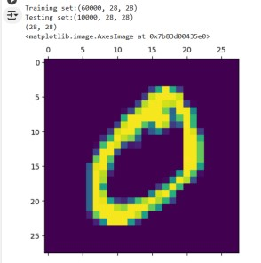

**Step 4 : Train a Model #Normalizing the dataset x_train=X_train/255 x_test=X_test/255**

**#Flatting the dataset in order to compute for model building x_train_flatten=x_train.reshape(len(x_train),28*28) x_test_flatten=x_test.reshape(len(x_test),28*28) x_train_flatten.shape**

**Step 5 : Make Predictions**

Use the model to make predictions based on the independent variable. model=keras.Sequential([ keras.layers.Dense(10,input_shape=(784,),

activation='sigmoid')

])

model.compile( optimizer='adam', loss='sparse_categorical_crossentropy', metrics=['accuracy'])

model.fit(x_train_flatten,y_train,epochs=5

)

**OUTPUT :**

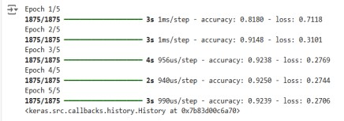

**Step 6 : Evaluate the Model** Evaluate the model performance. model.evaluate(x_test_flatten,y_test)

**OUTPUT :**



**RESULT:**

This step-by-step process will help us to implement Single Layer Perceptron models using the Keras dataset and analyze their performance.